Introduction

Video Streaming Service - Performance Testing
Performance testing ensures streaming platforms handle 100+ concurrent viewers without buffering, crashes, or silent failures.

Overview:

Test Type | Purpose | Key Metrics | Target Users | Expected Outcome
Load | Normal capacity | RT <3s, Error <5% | 50-200 | PASS up to 200
Stress | Breaking point | CPU 100%, Crash | 250-400 | FAIL at 300+
Scalability | Auto-scaling | Stable RT, +Throughput | 100→400 | PASS
Soak | Long-term stability | Memory leak detection | 100 (72h) | FAIL (+2.4GB leak)

load testing
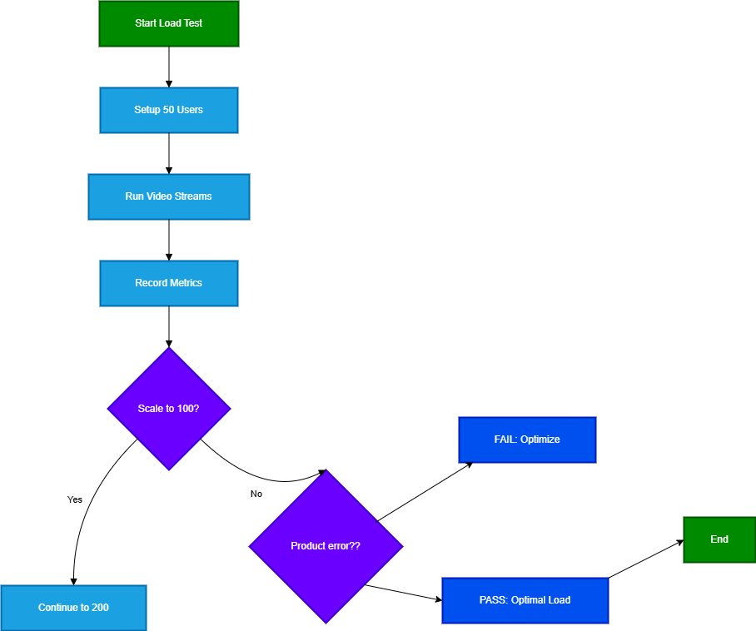

Stress testing
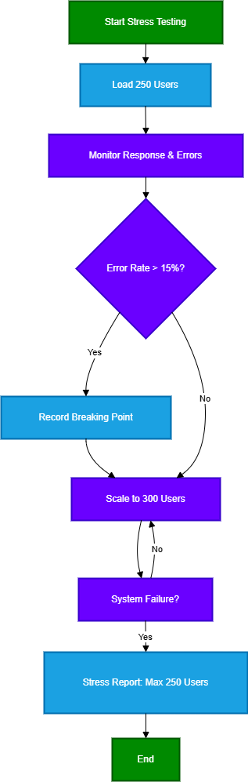

Scalability testing
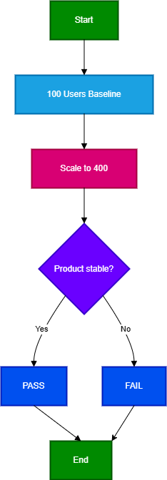

SCALABILITY FLOWCHART

soak testing
